Design-research work

**Calculation of plasma in tokamaks**

The author of the project:

Smirnov-Blagodarov Artem Vladimirovich

Contacts: +79313140102(telegram, whatsapp)

Artsmibla@yandex.ru

Saint-Petersburg

2022г

**Table of contents**

Passport of design and research work .......................................................................................3

Introduction.............................………………………………………..…….…...…………….6

Chapter I. Introductory part ..............................................................……………………........7

1.1. Relevance and goals............................................……………………….………………...7

1.2. Physical model..........................................…………………………….….………..……..8

Chapter II. The theoretical part................................................................................................11

2.1.More information about the calculation of forces .............................................................11

2.2. Reaction mechanism.........................................................................................................12

2.3.Tunnel effect........................…………………….………..……………………………....14

2.4. Calculation of efficiency.....................................................…………….……………….16

Chapter III. The final part........................................................................................................17

3.1. Project problems................................................................................................................17

3.2.Results................................................................................................................................18

3.3. Some clarifications..............................……………….………………………………….18

References................................................................................................................................19

Appendix No. 1 – Calculation of the ratio of energy consumed by humanity to the received…………………………………………………………………….………………...20

Appendix No. 2 – Some trial runs of the program...................................................................21

Appendix No. 3 – More information about the work of the program………………………..24

**Introduction**

Before we talk about controlled thermonuclear fusion technologies, I want to be sure that the reader is not subject to the widespread erroneous misconception that all nuclear power is dangerous - we can definitely say that NOT all. To begin with, do not confuse nuclear energy and nuclear bombs: nuclear bombs were created to be dangerous, while energy was created to raise the standard of human life. Nuclear reactors operating on the decay of heavy nuclei are really dangerous. Their principle of operation is based on the fact that a person controls and restricts the chain reaction of fission of uranium nuclei and extracts energy from this process. If this fragile balance is disturbed, for example, a slightly smaller amount of an inhibitor substance will be fed into the core chamber than necessary, and the system will go out of balance, excess neutrons will divide all new nuclei, and those in turn will emit new neutrons. As a result, in an avalanche way, it will come to an explosion or, at best, to an uncontrolled surge of energy. In reactors operating at the junction of light nuclei, the opposite is true. Here, on the contrary, a person should apply forces not to restrain the reaction process, but to maintain it - this alone proves the impossibility of an explosion of a thermonuclear reactor, with all this, excess energy can be extracted. Some advantages, wouldn't you agree? But not everything is so simple. So far, this surplus has not been obtained anywhere on Earth, and there is not enough theoretical basis in modern physics to explain the reason for this. The hypothesis of my project is that this surplus can exist in principle.

Also in the introduction, I want to ask the reader to be condescending to the number of theoretical assumptions that I have allowed myself. Plasma physics is very difficult to describe: the coordinate and velocity depend on time and acceleration, acceleration depends on forces, forces depend on coordinates, some forces also depend on speed, all this is in an external magnetic field, quantum effects and complex processes of nuclear reactions add fuel to the fire. Assumptions are simply necessary here, but in the process of improving the program code, you need to get rid of these assumptions.

**Chapter 1. Introductory part**

**1.1. Relevance, goals**

The most acute global problem that humanity is currently facing is the problem of lack of energy. The lack of strong public attention to this problem is explained by the fact that nowadays in many countries energy is available to the general consumer in such a volume that it is not necessary to notice its shortage. In reality, this state of affairs is a time bomb. The fact is that 87% of the energy supplied to the consumer is extracted from fossil sources. Fossil sources - in fact, represent the interpreted energy of the Sun, accumulated in the bowels of our planet for millions of years. Having carried out simple calculations (Appendix 1), it can be calculated that humanity spends 17 times more energy per unit of time than it receives from the Sun. According to various estimates, the fossil sources will last at best for 200 years. Thus, we simply leave the solution to the problem of lack of energy to our descendants. I would also like to note that many of the problems that public opinion is focused on are actually derived from the problem of lack of energy. Thus, the re-concentration of greenhouse gases in the Earth's atmosphere is the result of burning fossil sources. Or the problem of emissions from various spheres of human production activity (chemical industry, ferrous metallurgy) is sometimes caused only by the fact that the processing or disposal of industrial waste is a very energy-intensive process, reducing the cost of energy would solve this problem. This list can be continued for a very long time, because practically no process of human activity is complete without energy expenditure. It is also obvious that potentially infinite and pure energy would give a powerful impetus to the development of science.

It is this kind of energy, pure and potentially infinite, that the introduction of nuclear fusion reactors can offer. Of course, my project is not intended to completely solve the global energy problem, but rather to bring its solution closer or at least pay attention to such a solution.

After all, the thermonuclear reaction is the second most energy-dense among all processes in the Universe (after the annihilation of matter and antimatter). Therefore, attempts to curb such energy are obviously promising.

Based on theoretical calculations, I propose a variant for calculating the behavior of particles in an external magnetic field. Delving into the most diverse areas of physics, I also choose the most effective and computer-friendly methods. The final version of the program takes the values of the initial input parameters and can output a variety of data at the output (for more information, see Chapter 2). All the code is written in the C++ programming language in the Visual studio 2022 Community edition development environment, as well as the newest version of the code, which I am constantly updating, is publicly available on the github site at the link (https://github.com/Avotiyao5/plasma ). Before starting the next subtitle, it should be added that even if the general model is incorrect, some ready-made functions for calculating physical quantities can be used in another model.

**1.2. Physical model**

Input parameters:

1)dt is the minimum period of time for which the change in particle acceleration is considered to be equal to 0. This is a key parameter of the program, it is at the same time a measure of the program's realism and directly affects the speed of program execution. The smaller the dt, the more accurately the result of the program execution will correspond to reality and the longer the program will be executed;

2)dt2 - the time interval through which the particles fly in;

3)t is the execution time (the time it would take in reality for such a particle movement);

4)R is the large radius of the toroidal chamber;

5)I is the value of the current in toroidal coils;

6)I 2 - the value of the current in the poloidal coils and in the solenoid;

7)v0 is the velocity vector of the departing particles

8)the geometric characteristics of the windings are borrowed from the official ITER website;

9) the type of incoming particles - deuterium nucleus, tritium nucleus, electron.

Output parameters:

1)trajectories of particle motion;

2) the number of reactions that occurred;

3) reactor efficiency.

The main statement of the model is that there is a certain period of time dt for which the change in the acceleration of the particle can be considered minimal. Thus, in the time interval dt, the motion of a particle from point A to point B can be considered equidistant.

The program finds all the forces acting on this particle at point A, knowing the mass of the particle, we will find the acceleration at point A, from here it is easy to find the displacement, that is, to find the final coordinate of the particle in dt time. At this new point, the program recalculates all the forces acting on the particle, finds the acceleration vector, and the cycle repeats.

Everything would be fine if the acceleration varied at least within one order. But especially near other particles, acceleration increases greatly, and dt is still the same, respectively, the particle makes a powerful leap in space, because of this, the movement of the particle increasingly resembles a broken line, although in reality this is not the case, so there is a need for dt to depend on acceleration so that the movement is smoother. And, on the other hand, where the particle is removed from other particles and the acceleration is small, excessive accuracy is not needed, there - dt can be increased to speed up the program.

It is also worth noting that the model calculates the action of all forces separately in a projection on three axes of the Cartesian coordinate system, finding a common vector or value only when it is required for calculations. This trick makes it much easier for other people to understand the operation of the program, as well as to avoid unnecessary calculations in the program, which increases the speed of execution.

From point 9 in the input parameters, you could notice that ionized charged particles immediately fly into the torus. When did they manage to ionize? The fact is that in my project I consider the behavior of plasma, and other states of matter, in this case gas, would be described by slightly different laws of physics: first of all, such particles would not be affected by such forces as the Lorentz force and the Coulomb force. This model does not consider gas, because it will not greatly affect the final result, because very high temperatures are observed in the plasma, so after ionization of the atom, which takes place immediately after colliding with other particles, it is unlikely that the atom will recombine back. Therefore, the ionization process itself is not described in the program, already separated nuclei and electrons fly into the torus, nevertheless, the ionization energy of atoms is included in the formula for calculating the efficiency of the reactor. A reasonable question arises, why then only nuclei should not fly into the torus, because electrons do not participate in nuclear reactions and do not benefit. The fact is that such an assumption would not correspond to reality, because in practice neutral atoms are injected into the plasma, not nuclei, while electrons, due to their charge, make a great contribution to Coulomb forces and therefore greatly change the behavior of the plasma.

Also an important part of the model is how the particles themselves are implemented in the code. This is not part of the physical model, but it is necessary for further understanding. All particles in the program are described through one four-dimensional array. The first stage is an array of three-dimensional arrays, each of which represents a separate type of particles (neutron, electron, deuterium, tritium, etc.). The second stage is an array of two-dimensional arrays, each of which represents individual particles of the same type. The third stage directly reflects the properties of a single particle, the third stage is an array of 10 arrays, each of which stores data about some characteristic of the particle.Exactly:

| the table shows the number of the array corresponding to this property of the particle | axis x | axis y | axis z |
| --- | --- | --- | --- |
| coordinate | 0 | 1 | 2 |
| speed | 3 | 4 | 5 |
| acceleration | 6 | 7 | 8 |
| time | 9 | | |

The last stage, the fourth, is an array that preserves the previous values of these properties of the particle - this is necessary, since the calculation of new properties is impossible without knowledge of the previous ones. So, for example, to find out a new coordinate along one of the axes, you need to know the value of the previous coordinate, the previous initial velocity and the current acceleration. The main provisions of the model are implemented in the code in the file main.cpp (lines approximately 300-500).

**Chapter 2. Theoretical part**

**2.1. More information about the calculation of forces**

Only two forces act on particles in a tokamak that have a charge: the Lorentz force and the Coulomb force between the particles, this despite the fact that the distance between the particles is large enough that there is no nuclear interaction (more on this in Chapter 4). the acceleration of free fall can be neglected, since it is incomparable in magnitude with other accelerations.

1. The Lorentz Force

,where q is the charge; v is the velocity vector



-the formula of the vector product in terms of coordinates

The greatest inconvenience is the search for magnetic induction (B) at the point. School textbooks claim that the field inside the toroid is homogeneous, but my calculations show that this is not the case: the maximum value of magnetic induction inside the torus differs from the minimum by more than two times. Coils can be approximated as rings, finding a magnetic field from a ring with a current flowing through it is not difficult if the point at which the magnetic field is to be found is equidistant from all sections of the ring, that is, if such a point lies on a straight line passing through the center of the ring and perpendicular to the plane of this ring. But a much more difficult task is to find the field from the ring at any point.

Let's divide the ring into sections where this part of the ring can be considered a straight segment. Trial runs of the program show that such areas can be quite large, since the field in the distance (closer to the center) from the edge of the ring does not change much. And near the edge, the value of the field is not so important to know, because if the charged particle was so close to the edge, it means that it had a very large kinetic energy and was able to break away from the area with a stronger magnetic field and now it will definitely fly out of the torus (in reality it will hit the walls of the reactor). Thus, it is possible to make the straight sections of the ring large enough (because the speed of the program depends directly on the number of these sections). As a result, it is necessary to add up the magnetic induction vectors according to the superposition principle to find the magnetic field from the ring, and then, according to the same principle, add up the magnetic induction vectors from all the rings to find the resulting toroid field at a given point. It is planned to install 18 toroidal windings, 6 poloidal windings, as well as a solenoid coil divided into 6 sections in the ITER reactor [7]. To simplify the calculations even more, one coil can be considered as one whole ring, despite the fact that in reality there may be hundreds of turns of wire in one coil. Then the final current in such a ring can be found by simply multiplying the initial current in the wire by the number of turns in the coil. This simplification greatly reduces the execution time of the program and at the same time does not greatly affect the accuracy.

So, now let's calculate the magnetic field at a given point. The magnetic induction from one small piece of winding is according to the Biot-Savart-Laplace formula:

The unknown quantity here is only the radius vector (r), but it can be found, since the coordinates of the wire segment and the coordinates of the point at which the field should be found are known.

Then we add all the magnetic inductions of all the small wire segments of all the coils vector-wise and find the field. From here you can find the Lorentz force. The Lorentz force search code is implemented in the file functions.cpp in the mfc(magnetic field counter) function.

2)The power of the Coulumb

This is one of the simplest forces described in the program. Coulomb's law depends only on the charges of two particles and the distance between them.



Thus, it is necessary to calculate the superposition of all electric fields from all charges at the point where the particle is located, and then multiply the resulting field by the charge of the particle. The charges are known, to find the distance, you can use the formula of the length of the vector in three-dimensional space :

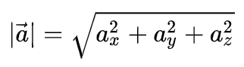

The difficulty here can only be that when sorting through particles when calculating the electric field from them, it is not possible to calculate the field from the particle itself in which this field is considered. Then the program will give an error. The Coulomb force search code is implemented in the file functions.cpp in the kfc(kulon force counter) function.

**2.2. Reaction mechanism**

Here, perhaps, begins the key and most difficult part of this project. Thermonuclear reactions ensure the performance of the tokamak. The principle of operation of the reactor is to create the necessary conditions for the start of these reactions. To calculate these conditions and describe them in the program is a difficult and unusual task for a student, because the mechanism of nuclear reactions is described by the laws of the microcosm, not classical physics. Also, before starting to delve into the theory, it is worth noting that the program considers such reactions conditionally instantaneous. Indeed, the average time of the thermonuclear reaction is about 10^-21 s[6], while the optimal time I found for dt in the program is 10^-13 s. Therefore, for interpretation into the code, we can say that at a certain point in time, if the conditions indicated below are met, others with new kinetic energies appear in place of two old particles.

* Overcoming the energy barrier of electrostatic forces.

, where Ucoul is the potential energy of the interaction of particles. Zi are the corresponding atomic numbers. e is an elementary charge. r =10^-15 (see below).

In order for a particle to overcome the Coulomb barrier, its kinetic energy component on the axis connecting the centers of the particles must exceed Ucoul

Many particles do not have sufficient energy, but reactions still occur due to the tunnel effect (for more information, see paragraph 2.3)).

* Minimum distance

To start the reaction, it is necessary that the particles are at such a distance when the strong nuclear interaction exceeds the Coulomb forces. Due to some provisions of the theory of quantum chromodynamics, which we will not delve into, such a distance is constant and does not depend on the charges of the nuclei, increases sharply at a distance equal to r0 = 10 ^ -15 meters. Therefore, the program assumes that when this distance is reached, the reaction occurs with one hundred percent probability.

Due to the fact that the forces of the strong interaction at such distances significantly exceed the rest, the graph of the potential energy in these places of the drop can be

considered “squared”,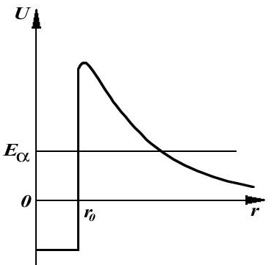 which will greatly simplify some calculations, without loss of accuracy.

* Particle motion after reaction

Of course, it is very difficult to determine exactly what happens to the particles during the reaction. At distances less than r0, extremely complex processes occur with particles: quark-antiquark pairs are born and annihilate in different places, nuclei exchange gluons with each other, quarks exchange “color” charges with each other. All this is complicated by the fact that the distances between different pairs of quarks are different, respectively, and their interaction forces are different. Therefore, in some rough approximation, we can consider the nuclei as material points that collided, and after their collision, new points with new masses, charges and energies flew out, which makes it possible to use the laws of conservation of energy and momentum on them. Thanks to this, we will be able to understand with some accuracy what will happen after the reaction. In reality, the trajectories of the particles after the reaction will differ slightly from such rough calculations, but not much: the directions of the velocity vectors of the departing particles somewhat depend on the spatial arrangement of the particles flying into the reaction, relatively speaking, on how sideways they were turned to each other, because the nuclei, if they consist of several nucleons, do not symmetrical. Such an assumption does not just simplify calculations - it makes them possible in principle, because such complex phenomena of the microcosm have not yet been discovered and described, and if they are described, they are not exactly laid out in open access, on the Internet.

**2.3 Tunnel effect**

Despite the fact that some particles in the plasma have sufficient kinetic energy to overcome the barrier, the number of such particles is very small. Such particles are called the “tail” of the Maxwell distribution,

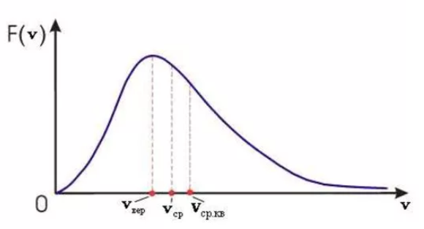,where v is the particle velocity, F is the number of particles with a given velocity. Thus, the probability of starting a reaction is extremely small, since Coulomb forces significantly slow down the particle until it reaches the distance r0. Consideration of the quantum nature of these particles helps to significantly increase this probability. Namely, the effect of quantum tunneling. Before giving the mathematical calculations describing this phenomenon below, it would be illogical not to conduct a small theoretical digression for a reader who has not been interested in quantum mechanics up to this point.

The tunnel effect is the ability of a corpuscle, without sufficient kinetic energy, to pass through a potential barrier with a higher energy[11]. People who are not familiar with quantum mechanics may mistakenly think that such an effect is exotic and happens extremely rarely. Indeed, from the point of view of classical physics, such a phenomenon is impossible or borders on the realm of fiction, for classical physics, quantum tunneling is the same as saying: water will boil before reaching 100 degrees, or saying that a body will be able to fly away from the gravitational field of the Earth, having an initial velocity below the second cosmic one. But in the microcosm there are slightly different laws, sometimes difficult for our understanding. In fact, quantum tunneling is a very common phenomenon, practically no synthesis or decay reaction is complete without a tunneling effect. In addition to applications in nuclear physics, tunneling is widely used in electrical circuits, because electrons can also tunnel. On this basis, the technology of such devices as: tunnel diode, field-effect transistors, various heterostructures, systems with oxide films, etc. has been developed[11]. Therefore, it is safe to say that the operation of the computer from which you are reading this text would be impossible if there were no such phenomenon as tunneling in nature.

The formula calculating the probability of a particle passing through a potential barrier is derived from the one-dimensional Schrodinger equation, the solution of which requires knowledge of higher mathematics of differential equations, so we will allow ourselves to use the ready-derived formula:

, where D0 = 1, a is the “width"[6] of the potential barrier, h is the reduced Planck constant, m0 is the mass of the particle, U0 is the barrier energy, E is the particle energy. This formula is only suitable for a fully square barrier: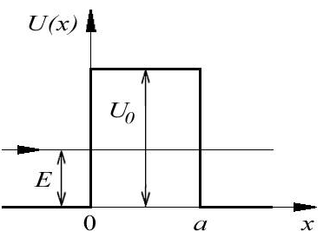. As mentioned above, for a distance of r0, the graph can be considered “square”, but when the distance is greater than r0, then the inverse dependence of the distance appears, and it would be a very gross mistake to consider the graph straight. Therefore, this formula is not suitable for describing our case. There are two options for how to proceed in this case: the first is to split our graph into a set of square ones and calculate the total probability through the product of the probabilities of these square ones: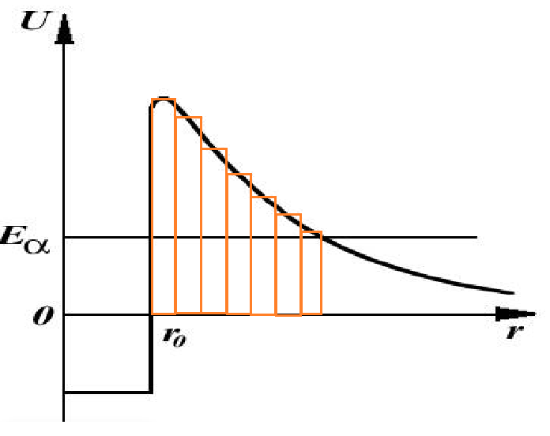; the second way is to use the formula for an arbitrary barrier graph, which includes integration. The second method will require some additional transformations, but it is much more accurate than the first, so of course I will choose the second method.

So, the formula for an arbitrary barrier shape is:

,then, according to the Newton-Leibniz formula, this expression can be written(<https://www.wolframalpha.com/> - online search for a primitive) as: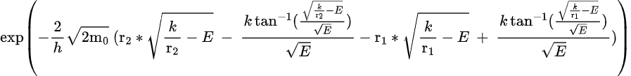

(<https://latexeditor.lagrida.com/> - building formulas)

, where k is the Coulomb constant, r2 and r1 are the points at which the kinetic energy of the particle coincides with the potential energy of the interaction of Coulomb forces.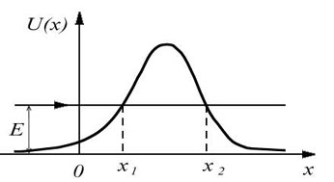All parameters from the above expression are either known or easily found. Thus, it is possible to find the probability of starting a reaction, even when the particles do not have sufficient kinetic energies. The code describing the reaction mechanism and calculating quantum tunneling and the reaction mechanism is implemented in the file functions.cpp in the nf(nuclear fusion) function.

**2.4. Calculation of efficiency**

Calculation of efficiency along with the Coulomb force is one of the simplest blocks of the program.

The initial kinetic energy of the particles that flew in and the ionization energy of deuterium (14.9eV) and tritium atoms are considered as the energy expended (unfortunately, no data could be found; by analogy with the increase in ionization energy from hydrogen (13.6eV) to deuterium (14.9eV), it can be assumed that the ionization energy of tritium also increases with the addition of a neutron at 1.3eV, that is, equal to 16.2eV). As a useful energy, the energy of the neutrons that fly out immediately after the reactions is considered, since the further trajectory of the neutrons can not be considered. Here it is worth proving in more detail the validity of such an assumption: neutrons do not have a charge, respectively, they can affect other particles only in direct contact, that is, in a collision, but we can say that the probability of such a collision in a low-density plasma is small, such a probability tends to zero, given that neutrons formed after a thermonuclear reactions have significantly higher velocities than other particles, accordingly, due to this, such neutrons fly out of the plasma cord region faster and fewer particles can meet on their way. All this makes it possible not to consider the movements of particles after the reaction. Such an assumption, of course, becomes extremely crude in a dense plasma. When running a large number of particles in a small volume, this part of the program becomes a weak point. Improving such weaknesses is one of my tasks in the further development of the project. The efficiency calculation code is partially implemented in the file main.cpp , partly in the nf function in the file functions.cpp .

**Глава 3. The final part**

**3.1. Project problems**

Lack of capacity

The calculations turned out to be very complicated for my home computer, so complicated that the calculation of the movement of five particles in a time equal to 10 to minus 8 seconds is carried out for about 6 hours. Of course, initially, before writing the project, I understood that such a problem would arise, but I thought that with a decrease in the geometric dimensions of the tokamak, it would be possible to achieve a sufficient concentration of particles in space to launch only a few dozen particles into the torus. It turned out that such a trick would not work. With a decrease in the geometric dimensions of the reactor chamber, the change in the value of magnetic induction per unit length increases, which requires consideration of much smaller values of dt, while it is necessary to maintain a high particle velocity so that it is able to overcome the Coulomb barrier, which was mentioned above. I solved the problems of lack of capacity by putting the code in open access. Perhaps someone who is also interested in thermonuclear fusion technology, having sufficient computing power, will use my code and run the program and get a reactor efficiency of more than 1 at the output, because the project tasks do not say that I should implement them.

The problem of accuracy

The problem of accuracy is very closely related to the problem of capacities. The computer has a limited number of possibilities, so it “cuts off” a certain number of digits after the decimal point of variables to simplify its calculations. It cannot be said that the motion of the particle modeled in this case will be fundamentally wrong. No, it simply will not correspond to reality, where space is continuous and where it is impossible to enter maximum accuracy on coordinates. Nevertheless, it is not necessary to underestimate the possibilities of modern computing technology.

The realism of the model

The presence of dt is the most important assumption of this project. In our reality, time is continuous, and it is incorrect to say that the values of forces change abruptly over time. At the same time, without the existence of dt, plasma modeling using computer calculations would be impossible at all. This problem is aggravated by the fact that it is not possible to conduct an experiment and compare the movement of a real particle with the movement of the particle that the program calculates, because perhaps they will coincide (I would like to believe it). At the same time, some theoretical considerations allow us to assert that within t, equal to 10 ^ -7 seconds, the movement of a particle in the program is close to real, in any case, the error is not observed with the naked eye, but this does not mean at all that with increasing t the error will not grow, on the contrary, it will most likely grow, even faster than t grows.

Lack of data

A lot of necessary parameters cannot be found on the Internet, not only because nuclear fusion is an advanced science, but also because, unfortunately, nuclear fusion is used not only for peaceful purposes. So, I could not find the following data:

plasma magnetic permeability; tritium ionization energy; the law by which the current in the tokamak solenoid fluctuates; the exact value of r0; (it would seem! but....)the values of the particle masses were quite different in different sources, etc.

The possibility of modeling plasma as such

The work of a computer that calculates the motion of plasma particles is based on the ordered motion of electrons. The philosophical question arises whether it is possible to calculate particles by the same particles. Constantly improving the accuracy of calculations, we gradually move away from the concept of modeling and strive for the concept of experiment (creating a copy of reality), but obviously we can never achieve it, which follows from the above problems. Wouldn't it be easier to immediately conduct an experiment in our reality and give up trying to model something? In my opinion, no, because attempts to simulate plasma make it possible to think more deeply about its nature from a theoretical point of view, and from experiments the theory is sometimes not at all clear.

**3.2 Result**

To evaluate the result of the project, I suggest looking at whether the tasks specified in the project passport were completed.

1) The code has been written, divided into thematic blocks, laid out in open access - this task has been completed.

2) A configuration of parameters has been found at which a balance has been achieved between the correspondence of the reality of the program and the speed of program execution.Namely:

R = 0.5 m; dt = 10 ^-13 c; v0 = 100000 m /s, the direction is tangent to the circle of the torus, deviating into the torus by 24 degrees; I = 68000 A; I2 = 45000 A; dt2 = 5 * 10 ^-11 - this task is also completed.

The execution of tasks 3 and 4 turned out to be impossible due only to the lack of computing power, all other steps on the way to the fulfillment of these tasks were made. In this regard, I set myself another task: to rebuild the code in the future so that a person who is not familiar with programming can use it, because at present such use is impossible. Such a step will help to expand the circle of people who, perhaps, testing my code at home, will be able to find such parameters at which the reactor efficiency is maximum.

**3.3. Some clarifications**

I have repeatedly used the above wording like “trial runs” or “some calculations”, a logical question arises: where are these calculations? The fact is that the main theoretical part of my project is the code. The code is the calculations, it can be viewed in the public domain, at the link that was given above. It would take a very long time to delve into the structure of the program, and I found it impractical, since the subject of my project is physics, not computer science.

If you want to learn more about how the program works, see Appendix No. 3. I also tried to make as many comments as possible in the program code.

**List of used literature**

| Books: | author | title | publishing house | year of publication | number of pages |
| --- | --- | --- | --- | --- | --- |
| 1 | E.V.Shpolsky | Atomic physics | “Лань” | 2022 | 448 |
| 2 | A.N.Matveev | Electricity and magnetism | “Высшая школа” | 1983 | 463 |
| 3 | Брайан Клегг | Hacking Quantum Physics | АСТ Москва | 2019 | 303 |
| 4 | Richard Feynman | A dozen lectures | БИНОМ | 2011 | 318 |
| 5 | A.M. Makarov, L.A. Luneva | Fundamentals of Electromagnetism | МГТУ им. Н.Э.Баумана | 2002 |  |
| 6 | L.K. Martinson, E.V. Smirnov | Quantum theory | МГТУ им. Н.Э.Баумана | 2002 |  |
| Sites | Title | link | date of use |  |  |
| 7 | ITER | <https://www.iter.org/ru> | september 2022 |  |  |
| 8 | ИТЕР Россия | <https://iterrf.ru> | september 2022 |  |  |
| 9 | Wikipedia | [https://ru.wikipedia.org/wiki/Термоядерная_реакция](https://ru.wikipedia.org/wiki/%D0%A2%D0%B5%D1%80%D0%BC%D0%BE%D1%8F%D0%B4%D0%B5%D1%80%D0%BD%D0%B0%D1%8F_%D1%80%D0%B5%D0%B0%D0%BA%D1%86%D0%B8%D1%8F) | december 2022 |  |  |
| 10 | Wikipedia | [https://ru.wikipedia.org/wiki/Сильное_взаимодействие](https://ru.wikipedia.org/wiki/%D0%A1%D0%B8%D0%BB%D1%8C%D0%BD%D0%BE%D0%B5_%D0%B2%D0%B7%D0%B0%D0%B8%D0%BC%D0%BE%D0%B4%D0%B5%D0%B9%D1%81%D1%82%D0%B2%D0%B8%D0%B5) | december 2022 |  |  |
| 11 | Wikipedia | [https://ru.wikipedia.org/wiki/Квантовое_туннелирование](https://ru.wikipedia.org/wiki/%D0%9A%D0%B2%D0%B0%D0%BD%D1%82%D0%BE%D0%B2%D0%BE%D0%B5_%D1%82%D1%83%D0%BD%D0%BD%D0%B5%D0%BB%D0%B8%D1%80%D0%BE%D0%B2%D0%B0%D0%BD%D0%B8%D0%B5) | december 2022 |  |  |
| 12 | Wikipedia | [https://ru.wikipedia.org/wiki/Токамак](https://ru.wikipedia.org/wiki/%D0%A2%D0%BE%D0%BA%D0%B0%D0%BC%D0%B0%D0%BA) | december 2022 |  |  |
| 13 | livejournal | <https://tnenergy.livejournal.com/3561.html> | october 2022 |  |  |

**Appendix 1. The ratio of solar energy consumed to received**

Given:

Solar constant - 1,366 kilowatts per square meter;

The projection of the land area is approximately 0.5 million square meters. Km;

The albedo of the Earth is 37%;

Every hour humanity uses 143,851 petawatts of electricity;

of these, 87 percent are fossil sources.

1)Total energy absorbed by the Earth=1,366*1000000*0,25*1000000*(100-37)/100=0,215*10^12

2) And now multiply by 3600, because the power was calculated in seconds and not hours

0,215*3,6*10 ^15=7.5 petawatts per hour

That is, the amount of solar energy consumed refers to the amount received as

144*87%/7,5=16,7

Humanity burns 17 times more energy than the Sun delivers to us. Now it is clear in what debt to the planet we continue to live, extracting oil and other minerals.

**Appendix 2. Some trial runs of the program**

*The graphs are plotted using the coordinates of particle motion using the gnuplot version 5.2 program(* [*http://www.gnuplot.info/index.html*](http://www.gnuplot.info/index.html) *)*

1. Unsuccessful launches; the graphs below show the trajectories of the particles.



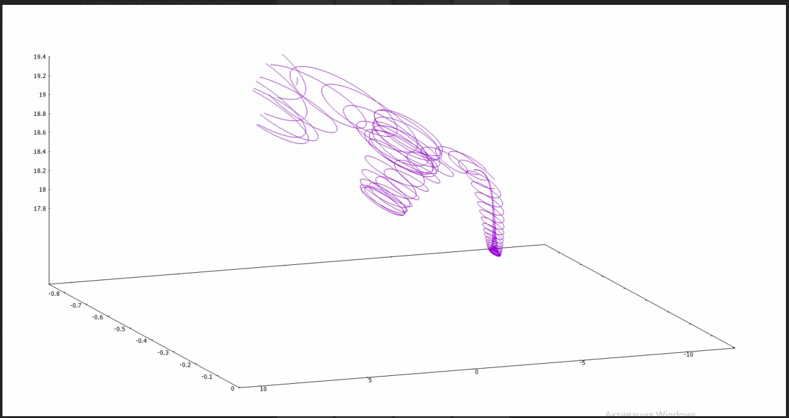

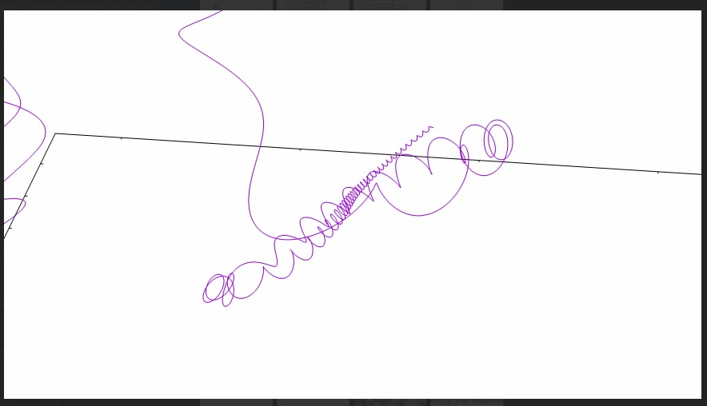

1. Successful

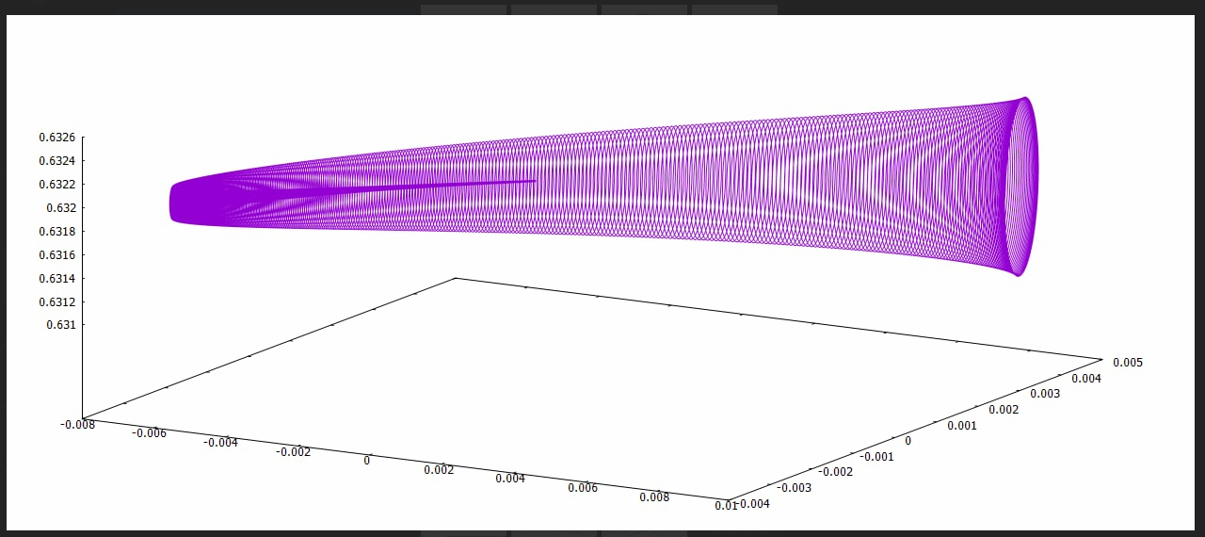



Configuration of coils in space (bottom)



**Appendix 3: More information about the program**

(Row values may change somewhat over time)

*File main.cpp*

Before proceeding to the part of the program that will be enclosed in a cycle corresponding to the flow of time, it would be rational to calculate in advance the configuration of the location of the reactor windings in space. This is what the code in lines 50-291 is responsible for. Lines 55-190 are responsible for the construction of the solenoid and poloidal coils. Lines 191-265 are responsible for the construction of toroidal coils. Lines 266-275 describe the turns on one of the coils, but it is better not to use these lines, because they load the program very much. Lines 278-291 record arrays of coordinates of vectors of winding sections. Lines 292-315, excluding the following code, construct the dependence of the magnetic field value on the coordinate.

Starting from line 329 onwards, the code responsible for the passage of time is recorded. This is a cycle, in each iteration of which the value of dt is added to the time value. The kinetic model of particle motion is described here, hence the call of functions calculating the forces acting on the particle is made. Lines 330-438 describe those particles that just flew into the torus, they need a separate description, since the main part of the input parameters is set through this part of the code. Lines 440-496 describe all other cases - that is, when the particle has been in the plasma for a long time.

File functions.cpp it is a set of functions that is called from 329-496.

The mfc function takes the value of the winding coordinates, the value of the coordinates of the point at which the field should be calculated and returns the magnetic field vector.

The kfc function takes a four-dimensional array of particles, the value of the coordinate of the particle for which it is necessary to calculate the coulomb force, and returns the intensity vector at this point.

The nf function takes an array of particles and searches among them for possible pairs for the reaction. And, if a reaction occurs, then for these two particles are removed from the array and new ones appear at the same point. Thus, this function returns a number of values: the numbers of particles to be deleted, 10 parameters for newly appeared particles.

You can find an even more detailed explanation of how the code works directly in the program itself( <https://github.com/Avotiyao5/plasma> ), there I tried to write as many comments as possible.